Architectural Blueprint — Keyfactor AgileSec Cryptographic Management

Multi-Account AWS Landing Zone, Hybrid Colocation, and Enterprise Integration Architecture

1. Executive Summary
This document defines the deployment, data collection, operationalization, and disaster recovery (DR) architecture for Keyfactor AgileSec, deployed as the enterprise's central platform for compiling a Cryptographic Bill of Materials (CBOM), evaluating cryptographic posture against regulatory guardrails, and executing a multi-year Post-Quantum Cryptography (PQC) migration.
AgileSec runs as a hub-and-spoke platform on Amazon EKS in a primary AWS region, with a Pilot Light disaster recovery footprint in a second region. It collects cryptographic telemetry from three environments — the AWS landing zone (100+ member accounts), AWS-hosted application workloads, and a hybrid on-premises colocation ("Colo") footprint — through three purpose-built, low-overhead ingestion pathways rather than a fleet of individually managed endpoint agents. Collected findings are evaluated against NIST, CISA, and NSA cryptographic transition guidance, enriched with business context from ServiceNow CMDB, and pushed into ServiceNow Vulnerability Response and Telos Xacta 360 to drive remediation and continuous Authorization-to-Operate (ATO) evidence.

2. High-Level Architecture Overview
This section defines the systems in scope, how they connect, and where the AgileSec platform itself runs. It replaces the single ASCII diagram in the original draft with two complementary, editable diagrams: a system context view (Figure 1) and a platform component view (Figure 2).

2.1 System Context
Figure 1 shows every system that exchanges data with AgileSec, the direction of each data flow, and which flows are DR/failover-only. Solid lines are normal operating paths; dashed lines are used only during a declared DR event.
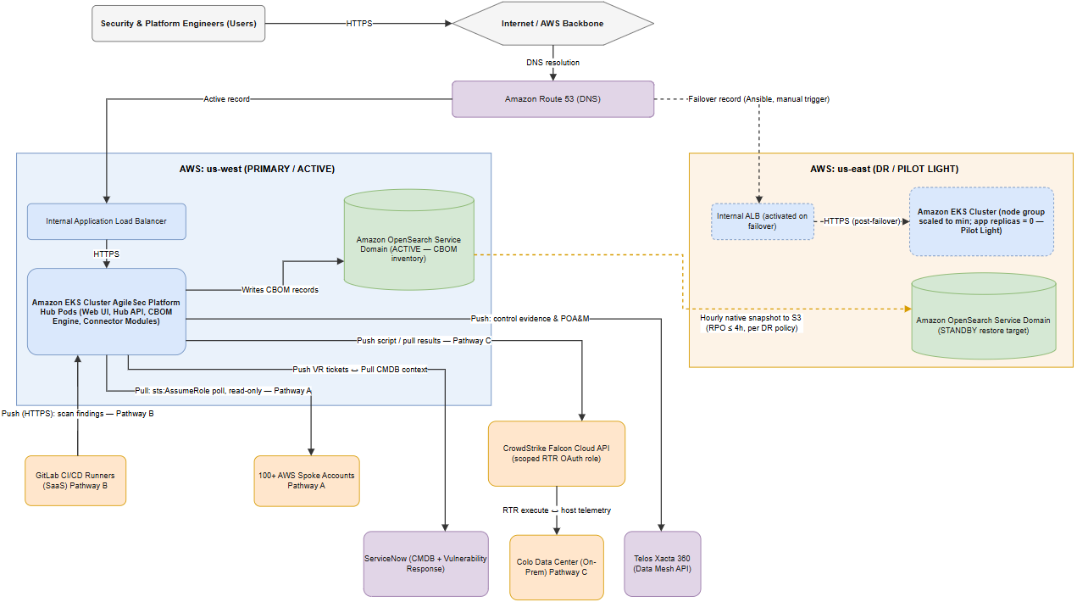
Figure 1 — System Context and High-Level Architecture
At the center of the architecture is the AgileSec Platform Hub, running on Amazon EKS in the primary AWS account (us-west), behind an internal Application Load Balancer and reachable only by security and platform engineers over HTTPS (Assumption: the Web UI is not exposed to the public internet; it is reached over a private network path — VPN, Direct Connect, or an internally-routed ALB — consistent with an "internal ALB" deployment). The Hub writes its inventory to an Amazon OpenSearch Service domain, which is the system of record for the CBOM.
Three ingestion pathways feed the Hub: Pathway A pulls from 100+ AWS spoke accounts using a read-only cross-account IAM role; Pathway B receives pushed findings from GitLab CI/CD pipelines; and Pathway C reaches the Colo data center indirectly through the CrowdStrike Falcon Cloud API. Two enterprise systems complete the picture: ServiceNow, which both supplies asset context to AgileSec and receives remediation tickets from it, and Telos Xacta 360, which receives compliance evidence and POA&M records. Each of these is described in full in Sections 4, 5, and 7.

2.2 AgileSec Platform Hub Component Architecture
Figure 2 opens up the "AgileSec Platform Hub Pods" box from Figure 1 into its constituent components. This is a logical component view — component names are Assumptions (labeled A) describing a reasonable internal structure for a platform with these responsibilities; AgileSec's actual internal module boundaries are proprietary to Keyfactor and not disclosed in vendor documentation reviewed for this blueprint. Treat this diagram as an operating model for how the platform behaves, not as its verified internal source structure.

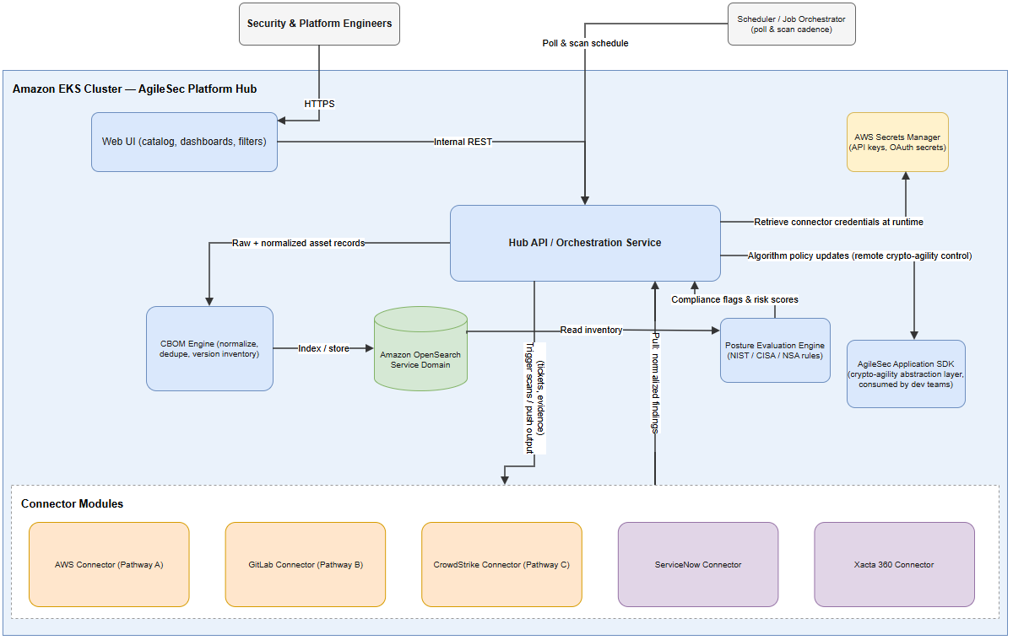
Figure 2 — AgileSec Platform Hub Component Architecture
- Web UI — the catalog, dashboards, and filtering interface security and infrastructure teams use in Phase 1 of Operationalization (Section 5.1).
- Hub API / Orchestration Service — the internal control point all other components pass data through; it retrieves connector credentials from AWS Secrets Manager at runtime rather than holding them in configuration.
- Scheduler / Job Orchestrator — owns poll and scan cadence for every connector (Section 4 gives the default cadence per pathway).
- Connector Modules — one module per external system (AWS, GitLab, CrowdStrike, ServiceNow, Xacta 360), each responsible for that system's authentication, API shape, and rate limits, so a change to one integration does not touch the others.
- CBOM Engine — normalizes and deduplicates raw findings from every pathway into a single versioned inventory and writes it to OpenSearch.
- Posture Evaluation Engine — reads the inventory and evaluates it against NIST/CISA/NSA guardrails, producing the compliance flags and risk scores used in Section 5.2.
- AgileSec Application SDK — the crypto-agility abstraction layer consumed by developers (Section 5.4); it is a client-side library, not an EKS-resident service, but is shown here because the Hub API pushes algorithm policy updates to it.

3. Infrastructure Deployment & Disaster Recovery Strategy

3.1 Multi-Region Design: Pilot Light Active/Passive
AgileSec is an analytical cryptographic-posture management tool, not an inline network control — a brief outage does not block production traffic. Given that, the architecture uses a Pilot Light disaster recovery pattern to balance reliability against runtime cost.
Note: Correction to the original draft: the source document labeled this pattern "Warm-Standby" while describing compute scaled to zero replicas. Per AWS Well-Architected DR terminology, a design that keeps data continuously or periodically replicated but scales application compute to zero — requiring it to be started on failover — is Pilot Light, not Warm Standby (which keeps a reduced but running fleet). This document uses Pilot Light throughout. If faster recovery is later required, this can be upgraded to true Warm Standby by keeping a minimum replica count greater than zero in us-east at all times — the tradeoff is continuous compute cost in the DR region.
- Primary Site (us-west) — a live Amazon EKS cluster hosting the AgileSec Platform Hub, behind an internal AWS Application Load Balancer (ALB), writing to an active Amazon OpenSearch Service domain.
- Disaster Recovery Site (us-east) — an identical infrastructure footprint provisioned by the same Terraform configuration. To eliminate idle compute cost, the EKS node group is scaled to its minimum and the AgileSec deployment's replica count is set to 0 until a failover is declared.
- Data Persistence — native Amazon OpenSearch Service snapshots are taken on a scheduled basis in us-west and copied to an S3 bucket, then restored into the us-east OpenSearch domain during failover (Section 3.4 gives the exact interval and the rationale for choosing scheduled snapshots over continuous cross-cluster replication).

3.2 Infrastructure as Code with Terraform
Terraform maintains state files for both regions to ensure configuration consistency between the primary and DR footprints.
- AWS Topology — provisions VPCs, subnets, internal routing, ALBs, EKS clusters, and OpenSearch Service domains uniformly across both regions from a shared module set, so the two regions cannot silently drift out of configuration parity.
- Global Governance — deploys an AWS CloudFormation StackSet from the management account into all 100+ spoke AWS Organizations accounts. The StackSet deploys a uniform, read-only AgileSec-CrossAccount-Role used by Pathway A (Section 4.3) to audit cryptography without granting write access to any spoke account.
- New-Account Onboarding (Assumption) — the StackSet is deployed with AWS Organizations service-managed permissions and automatic deployment enabled, so that any new account created under the covered Organizational Units automatically receives the AgileSec-CrossAccount-Role without a manual step. Confirm this is how the StackSet is currently configured; if it is deployed as a self-managed StackSet instead, every new account requires a manual stack-instance addition and is a coverage gap until that happens.
Terraform state itself should be stored in a versioned, encrypted S3 backend with DynamoDB state locking, and changes should go through a pull-request-gated CI/CD pipeline rather than being applied ad hoc from an engineer's workstation (Assumption — not specified in the original material, added as standard IaC governance practice).

3.3 Platform Orchestration with Ansible
Ansible handles the life-cycle configuration of the running AgileSec software; it does not provision cloud infrastructure — that is Terraform's responsibility (Section 3.2).
- Internal Platform Configuration — interacts with the AgileSec REST API to push scan schedules, build asset grouping tags, and import organizational compliance rules.
- Automated DR Failover Actions — a playbook (dr-failover.yml) that, once invoked, scales up the EKS deployment in us-east, restores the latest OpenSearch snapshot into the us-east domain, reconnects the Hub pods to it, and updates the Amazon Route 53 record to point to the us-east ALB. Section 3.5 walks through this sequence and defines what invokes it.

3.4 DR Objectives: RTO, RPO, and Failover Trigger
These targets and the replication mechanism below reflect your decisions; the original document specified neither.
Parameter | Value | Basis
Recovery Time Objective (RTO) | ≤ 24 hours | Your direction — appropriate for an analytical/posture-management tool that does not sit inline in production traffic.
Recovery Point Objective (RPO) | ≤ 4 hours | Your direction.
Replication mechanism | Scheduled native Amazon OpenSearch Service snapshots to S3, restored into us-east on failover | Your direction, chosen over continuous cross-cluster replication (CCR) for lower operational complexity and cost; CCR requires matching domain versions/configuration between regions and adds an always-on replication pipeline that this design does not need to hit a 4-hour RPO.
Snapshot interval | Hourly (Assumption — confirm against your actual change rate) | An hourly cadence gives an RPO of at most 1 hour under normal conditions, comfortably inside the 4-hour target with margin for a missed or delayed snapshot run.
Failover trigger | Manual, runbook-driven | Your direction — an on-call engineer confirms the primary-region outage and manually invokes the Ansible failover playbook, rather than an automated health check doing so. See the residual risk note below.

Note: Residual risk: because there is no automated health-check/monitoring system described elsewhere in this architecture, detection of a primary-region outage depends on some other alerting path (e.g., AWS Health Dashboard notifications, EKS/ALB CloudWatch alarms feeding an on-call paging tool) that is out of scope for this document. Recommend confirming that path exists and is tested; otherwise the effective RTO includes however long it takes someone to notice the outage, not just the 24 hours budgeted for the mechanical failover steps below.

3.5 DR Failover and Failback Procedure
Figure 4 lays out the failover sequence step by step, including the failback procedure — which the original document never described (it covered only failover, not the return to primary).

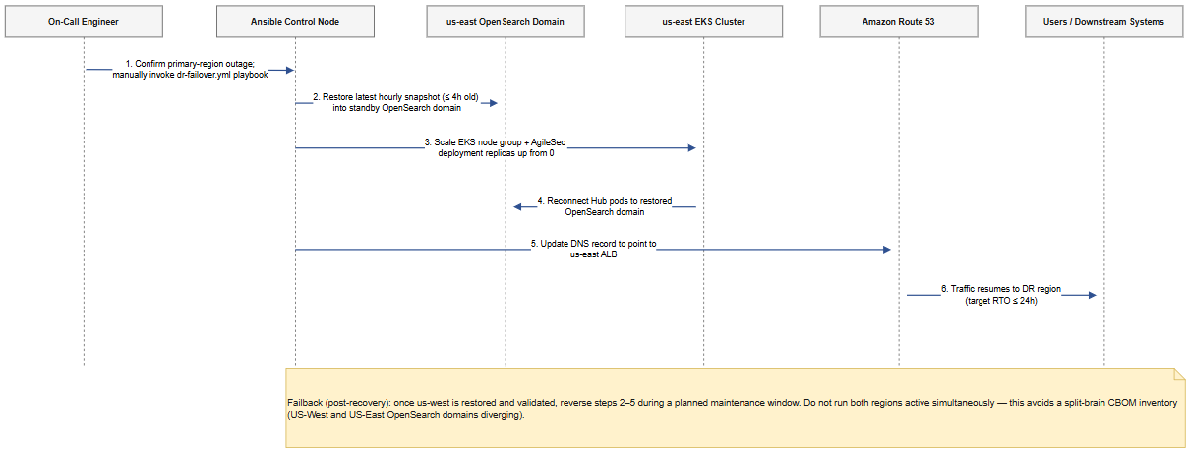
Figure 4 — DR Failover Sequence
- The on-call engineer confirms the primary-region (us-west) outage through the organization's monitoring/alerting path and manually invokes the dr-failover.yml Ansible playbook. This manual confirmation step exists specifically to avoid an unnecessary failover being triggered by a transient or false-positive health signal.
- The playbook restores the latest hourly OpenSearch snapshot (at most 4 hours old under the RPO target) into the standby us-east OpenSearch domain.
- The playbook scales the us-east EKS node group up from its minimum and sets the AgileSec deployment's replica count above 0.
- The newly-started Hub pods in us-east connect to the restored OpenSearch domain.
- The playbook updates the Amazon Route 53 record to point to the us-east ALB.
- Traffic — both the Web UI and every inbound connector callback — resumes against the DR region. Target RTO for this entire sequence is 24 hours; in practice the mechanical steps should complete in well under an hour once invoked, with most of the RTO budget as headroom for outage detection and engineer response time.
Failback (post-recovery): once us-west is confirmed restored and validated, reverse steps 2–5 during a planned maintenance window. Do not run both regions active simultaneously — doing so would let the two OpenSearch domains diverge (a split-brain CBOM inventory), and reconciling two independently-updated cryptographic inventories after the fact is error-prone and could hide or duplicate findings.

4. Data Collection Framework: Deployment-Time vs. Run-Time Telemetry
To collect cryptographic telemetry from hundreds of decentralized environments without deploying and managing hundreds of individual endpoint agents, AgileSec splits ingestion into three low-overhead pathways, and — orthogonally — into two temporal phases: deployment-time (static, shift-left) and run-time (live, dynamic). This section replaces the original document's Section 3, which existed in three separate, partially-conflicting versions (an initial "Practical Data Collection" section, a later table-plus-duplicated-prose patch, and a further revision that silently overwrote both); Appendix A documents exactly how they were reconciled.

4.1 Overview and the Three Ingestion Pathways
AgileSec splits telemetry collection into three low-overhead pathways, avoiding the need to deploy and manage individual endpoint agents across hundreds of decentralized environments: Pathway A (AWS Infrastructure Layer, zero-agent, cross-account pull), Pathway B (Application Layer, GitLab CI/CD push), and Pathway C (Hybrid Colo Footprint, via CrowdStrike RTR). Each pathway operates at both deployment-time and run-time, described next.

4.2 Deployment-Time Telemetry (Static Gates)
This phase catches cryptographic vulnerabilities in code and configuration before they are provisioned into infrastructure, preventing risk from going live in the first place.
- Source Code & Artifact Scanning (Pathway B — GitLab CI/CD): a mandatory GitLab Group-level CI/CD component intercepts every developer pipeline in the organization. It downloads the AgileSec CLI (binary name: unified_sensor) to run a local Abstract Syntax Tree (AST) scan of application code, third-party dependencies, and container base images for legacy cryptography — for example, hardcoded RSA keys or known-vulnerable OpenSSL versions.
- Infrastructure-as-Code (IaC) Auditing (AWS Cloud Infrastructure): the same GitLab runner execution uses the AgileSec CLI to parse Terraform files, flagging insecure configurations such as load balancers negotiating weak TLS cipher suites or unencrypted S3 buckets. The pipeline build fails if a configured risk threshold is breached, so the insecure configuration is never applied.
- Golden Image Auditing (Colo): before an OS image or VM template (OVA) is shipped to the Colo, it passes through a GitLab CI pipeline where the AgileSec CLI audits its built-in root certificate stores and local cryptographic libraries.
Prerequisite (Assumption): this pathway requires a GitLab subscription tier that supports Group-level CI/CD component definitions, and requires GitLab.com (SaaS) network reachability from every runner to the AgileSec Hub's public HTTPS endpoint. If GitLab is self-managed on-premises rather than SaaS — not stated in the source material — the network path in Figure 1 changes: runner-to-Hub traffic would need a private route (VPN or Direct Connect) rather than the public internet path shown.

4.3 Run-Time Telemetry (Live Posture)
This phase continuously audits the active state of the production environment: ephemeral keys, live network handshakes, and actual (not just declared) infrastructure behavior.
- Multi-Account AWS Cloud Control Plane (Pathway A): the Hub polls AWS KMS, ACM, and IAM every few hours across all 100+ spoke accounts using the Terraform-deployed, read-only cross-account IAM role, building an index of active keys, certificate expiration dates, and cloud-native certificate material. It also ingests ELB access logs and VPC Flow Logs to capture the encryption strength of live client-to-server TLS handshakes.
- Active Network & Live Workloads: for containerized applications on EKS/ECS, short-lived AgileSec scanner pods run inside the live cluster to audit in-memory cryptographic modules of running containers — catching runtime state that static scanning of a container image cannot see (for example, a library loaded and configured differently than its default).
- Live On-Premises Host Inspection (Pathway C — CrowdStrike RTR): for the Colo footprint, AgileSec connects to the CrowdStrike Falcon Cloud API and triggers CrowdStrike's Real-Time Response (RTR) engine to scan live server filesystems, active Java Keystores (JKS), and open network listening ports on running Colo servers, tunneling the resulting telemetry back to the AWS Hub through the CrowdStrike cloud network.
Note: Correction to the original draft: the source material described the AWS cross-account role as an "administrative assume-role pattern" in this section while Section 3.2 (of the original) defined the same role as read-only. In a security architecture document, "administrative" access is a materially different (and concerning) claim from "read-only." This document uses read-only, least-privilege cross-account IAM role consistently — Section 3.2's definition is treated as authoritative since it is the more specific and deliberate statement.
Note: Recommendation: the CrowdStrike OAuth client used for Pathway C should be scoped to a custom Falcon role limited to Real Time Response and Real Time Response Administrator permissions only — the minimum needed to push and execute the specific host-scanning script — rather than broader Falcon console administrative rights. The original material's phrase "administrative access" for this OAuth client is accurate to CrowdStrike's permission model (RTR script execution does require an RTR-admin-capable role) but should be scoped this narrowly rather than granted at the full Falcon-console-admin level.
Prerequisite (Assumption): Pathway C depends on the CrowdStrike Falcon sensor already being installed and healthy on every in-scope Colo host, with the RTR module licensed and enabled. Any Colo host without a healthy Falcon sensor is a blind spot for this pathway and will not appear in the CBOM from run-time collection (it may still be partially covered by Section 4.2's golden-image auditing if it was provisioned from an audited image). Recommend a periodic reconciliation between the Colo asset inventory (e.g., the ServiceNow CMDB, per Section 4.6) and the set of hosts reporting through Falcon, to surface coverage gaps.
Scan cadence (Assumption — not specified in the original material): CrowdStrike RTR Colo scans default to a daily schedule, configurable per asset-criticality tier once ServiceNow CMDB enrichment (Section 4.6) is in place — for example, Tier 1 systems could run more frequently than Tier 3.

4.4 Data Collection Flow
Figure 3 shows all six collection points (three pathways × two temporal phases) and how each reaches the Hub, including which side initiates the connection (push vs. Hub-initiated pull) — a distinction the original ASCII diagram did not make clear.
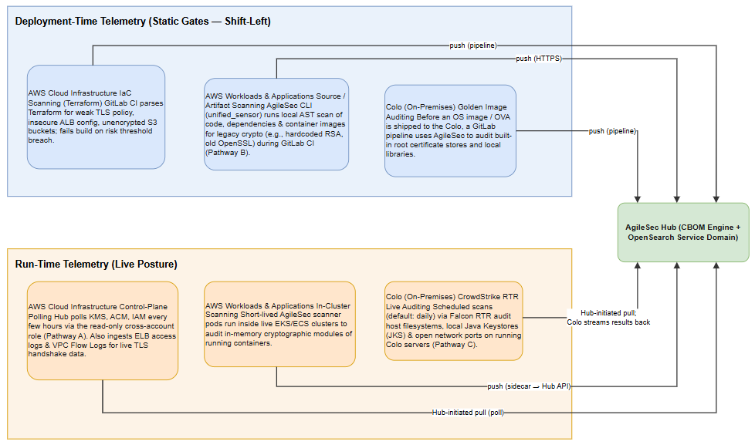
Figure 3 — Data Collection Flow: Deployment-Time vs. Run-Time

4.5 Data Collection Matrix
This table is the quick-reference summary of Sections 4.2 and 4.3; it intentionally does not repeat their full explanatory detail.
Environment | Deployment-Time (Static / Shift-Left) | Run-Time (Live / Dynamic)
AWS Cloud Infrastructure | Terraform scanning: the AgileSec CLI parses Terraform files for weak TLS policies, insecure ALB configuration, or unencrypted S3 buckets before deployment; fails the build on risk-threshold breach. | Control-plane API ingestion: live polling of AWS KMS, ACM, and IAM every few hours via the read-only cross-account role. Network traffic inspection: ingests VPC Flow Logs and ELB access logs to capture live TLS handshake negotiations.
AWS Workloads & Applications | GitLab CI/CD static scan: the AgileSec CLI (unified_sensor) scans source code, package dependencies, and container images (Dockerfile) for legacy crypto libraries (e.g., old OpenSSL) during the build phase. | Ephemeral container pods: short-lived AgileSec scanner pods run inside live EKS/ECS environments to monitor active cryptographic modules running in memory.
Colo (On-Premises) | Golden image auditing: before an OS image or VM template (OVA) ships to the Colo, a GitLab CI pipeline runs the AgileSec CLI against its built-in root certificate stores and local libraries. | CrowdStrike RTR live auditing: scheduled scans (default: daily) triggered via CrowdStrike's API audit running local machine keystores, active filesystems, and open network listening ports on active Colo servers.

4.6 ServiceNow CMDB Enrichment Layer
Integrating with ServiceNow CMDB changes how AgileSec categorizes what it finds: instead of evaluating every finding with equal weight, it uses an API connector to map discovered assets against the enterprise configuration database before scoring risk.
- CMDB Enrichment (pull): before processing scanned hosts or AWS accounts, AgileSec calls the ServiceNow CMDB Instance API to pull environment context — Asset Criticality (e.g., Tier 1 vs. Tier 3), Application Owner, and Regulatory Classification (e.g., FedRAMP, HIPAA).
- Dynamic Prioritization: if an insecure RSA-1024 key is found on an active endpoint, AgileSec references the CMDB data to determine whether the server supports a mission-critical financial application or an isolated development sandbox, and adjusts the threat score accordingly.
This enrichment step feeds directly into Posture Evaluation (Section 5.2) and is what makes the risk scoring there context-aware rather than purely technical.

4.7 CBOM Data Model (Overview)
The original material references specific CMDB and compliance fields (Asset Criticality, Application Owner, Regulatory Classification, Configuration Item) without ever stating the underlying data model those fields attach to. The following is an Assumption — a minimal, reasonable model inferred from the integrations described, not a disclosed AgileSec schema — useful for anyone building reports or additional integrations against the CBOM.
Entity | Key Attributes | Populated By
Asset | Asset ID, environment (AWS account / Colo host), asset type, CMDB Configuration Item (CI) link | Pathways A, B, C (Section 4.2–4.3)
Certificate / Key | Identifier, algorithm, key size, issuer, expiration date, storage location (KMS, ACM, JKS, filesystem) | Pathways A, C
Algorithm Finding | Algorithm name, classification (compliant / weak / deprecated), detection source, first-seen / last-seen timestamps | CBOM Engine, from all three pathways
Compliance Mapping | Applicable framework (NIST SP 800-53, FedRAMP, DoD CC SRG), control ID, pass/fail state | Posture Evaluation Engine (Section 5.2); pushed onward to Xacta 360 (Section 7.2)
CMDB Context | Asset Criticality tier, Application Owner, Regulatory Classification | ServiceNow CMDB Enrichment (Section 4.6)

5. Operationalization: How the Platform Is Used
This section describes how the platform is used operationally, day to day. It restores and extends the original document's four operationalization phases, which were silently dropped when a later patch overwrote this section with ServiceNow/Xacta-specific content instead of merging with it (Appendix A, item A).

5.1 Phase 1 — Establish CBOM Baseline
The security engineering team uses the Web UI to view the global hybrid catalog of certificates, algorithms, and key sizes collected through the pathways in Section 4. Filtering by Provider == AWS vs. Provider == On-Prem splits visibility between cloud and infrastructure teams, so each team sees the subset of the CBOM relevant to systems they own.

5.2 Phase 2 — Posture Evaluation & Policy Matching
The platform evaluates the incoming inventory — enriched with ServiceNow CMDB context from Section 4.6 — against modern regulatory guardrails (NIST, CISA, and NSA transition timelines). Assets using vulnerable classic algorithms (for example, RSA keys shorter than 2048 bits, 3DES, or SHA-1 hashes) are automatically flagged Non-Compliant, with a risk score adjusted by the asset's CMDB-derived criticality tier.

5.3 Phase 3 — Automated Remediation Ticketing
AgileSec hooks directly into enterprise IT Service Management (ITSM) platforms to convert findings into tracked remediation work. ServiceNow Vulnerability Response is the primary, most deeply integrated path (Section 7.1); Jira is retained as a basic alternate destination for teams not yet onboarded to ServiceNow VR (Interpretation — the original material named both "ServiceNow or Jira" for generic ticketing but only detailed the ServiceNow-specific integration in a later revision; this document treats ServiceNow VR as the flagship path with CI mapping and SLA automation, and Jira as a simpler ticket-create-only fallback, rather than assuming Jira support was fully replaced).
- When a quantum-vulnerable algorithm is flagged on a Colo database server, a remediation ticket is generated and routed to the infrastructure team.
- When a weak TLS policy is found in a spoke AWS account, the respective cloud team is alerted.
- ServiceNow VR tickets carry an SLA and escalate automatically on breach (Section 7.1 gives the mechanics); the Jira fallback path creates a ticket but does not carry this automation.

5.4 Phase 4 — Developer Crypto-Agility
Engineers embed the AgileSec Application SDK into the core DevOps landing-zone blueprints. Developers write code referencing this abstraction layer rather than calling native, hardcoded cryptographic packages directly. When a shift to quantum-safe alternatives (such as ML-DSA) is mandated, the security team can update the algorithm remotely through the platform console without forcing every consuming application team to rewrite or recompile their code.
This is the mechanism behind the Enable Crypto-Agility phase of the PQC Migration Roadmap (Section 6.2): the SDK is what makes a centrally-driven algorithm swap possible instead of a multi-team code change campaign.

5.5 Phase 5 — Continuous Compliance via Telos Xacta 360
Once AgileSec processes deployment-time and run-time telemetry and evaluates posture, it pushes structured findings into Telos Xacta 360 to automate continuous risk management and ATO evidence. Full mechanics are in Section 7.2; in the operational flow, this is the terminal step for both a Compliant finding (an evidence pass) and a Non-Compliant finding that has been through remediation ticketing (a POA&M).

5.6 Operationalization Workflow
Figure 6 ties Phases 1 through 4 together into a single workflow, including the ServiceNow CMDB enrichment step that precedes Phase 2, the branch into Xacta 360 evidence vs. POA&M, and the feedback loop from Phase 4's crypto-agility capability back into fewer future non-compliant findings.
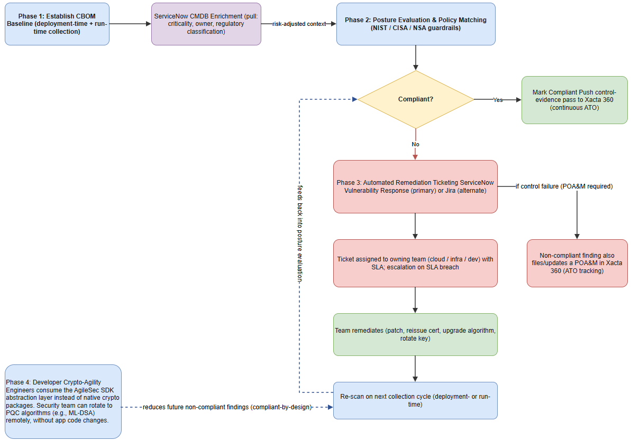
Figure 6 — Operationalization Process Workflow

5.7 Roles & Responsibilities (RACI)
The original material names teams informally ("security engineering team," "infrastructure team," "cloud team," "dev teams") without formally assigning responsibility. The table below is an Assumption that should be confirmed and adjusted against your actual org chart.
Activity | Responsible | Accountable | Consulted | Informed
CBOM baseline review (5.1) | Security Engineering | Security Engineering Lead | Cloud / Infra Teams | CISO
Posture evaluation & policy tuning (5.2) | Security Engineering | Security Engineering Lead | Compliance / GRC | Cloud / Infra / Dev Teams
Remediation ticket execution (5.3) | Owning Cloud / Infra / Dev Team | Team Lead of owning team | Security Engineering | Security Engineering, GRC
SDK adoption in landing-zone blueprints (5.4) | DevOps / Platform Engineering | Platform Engineering Lead | Security Engineering, App Dev Teams | CISO
Xacta 360 evidence & POA&M review (5.5 / 7.2) | GRC / Compliance | Authorizing Official (AO) | Security Engineering | CISO
DR failover execution (3.5) | On-Call Engineer | Platform Engineering Lead | Security Engineering | CISO, Application Owners

6. MITRE Framework Alignment
MITRE fits into this cryptographic management and PQC migration framework across two distinct domains: governance and compliance (the playbook) and threat mitigation (the technical defense). This AWS/Colo implementation satisfies both MITRE's governance roadmap and active ATT&CK defense requirements.

6.1 Governance: The MITRE PQC Migration Roadmap
MITRE is not only a cybersecurity tracking matrix vendor; MITRE also leads the Post-Quantum Cryptography Coalition (PQCC). Keyfactor AgileSec acts as the mechanical tool that executes the structural phases defined in MITRE's PQC Migration Roadmap.
MITRE Roadmap Phase | MITRE Requirement | How AgileSec Fits
Phase 1: Baseline Understanding | Organizations must build a comprehensive inventory of cryptographic assets and prioritize critical resources. | Generates the Cryptographic Bill of Materials (CBOM) using the deployment-time and run-time collection pipelines (Section 4), enriched with CMDB criticality data (Section 4.6) for prioritization.
Phase 2: Monitoring & Evaluation | Organizations must establish robust tracking measures to assess cryptographic security as quantum threats evolve. | Provides real-time PQC-readiness scores and tracks multi-account compliance gaps on a continuous dashboard (Section 5.1–5.2), with evidence pushed to Xacta 360 for formal continuous monitoring (Section 7.2).

6.2 PQC Migration Roadmap Timeline
The five migration phases below give the multi-year PQC migration roadmap that the original document's introduction promised but never actually laid out anywhere in the material provided. Durations are Assumptions (relative year/quarter ranges) meant as a planning starting point, not a committed program schedule — align them with your organization's actual PQC program timeline.
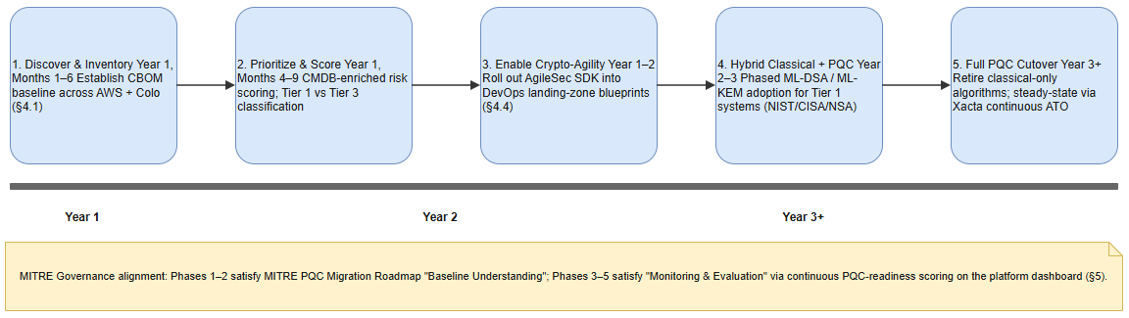
Figure 7 — PQC Migration Roadmap Timeline
- Discover & Inventory (Year 1, Months 1–6): establish the CBOM baseline across AWS and the Colo (Section 5.1).
- Prioritize & Score (Year 1, Months 4–9, overlapping with discovery): apply CMDB-enriched risk scoring; classify assets into Tier 1 vs. Tier 3 (Section 4.6).
- Enable Crypto-Agility (Year 1–2): roll out the AgileSec SDK into DevOps landing-zone blueprints (Section 5.4) so that a future algorithm change does not require an application rewrite.
- Hybrid Classical + PQC (Year 2–3): begin phased ML-DSA / ML-KEM adoption for Tier 1 systems, sequenced per NIST/CISA/NSA transition timelines.
- Full PQC Cutover & Continuous Compliance (Year 3+): retire classical-only algorithms organization-wide; operate steady-state through Xacta 360 continuous ATO validation (Section 7.2).

6.3 Technical Defense: Mapping Cryptography to MITRE ATT&CK
From an operational perspective, weak cryptography management directly enables real-world adversary behavior mapped in the MITRE ATT&CK matrix. Run-time tracking lets AgileSec disrupt adversary Tactics, Techniques, and Procedures (TTPs) at multiple points in the kill chain.
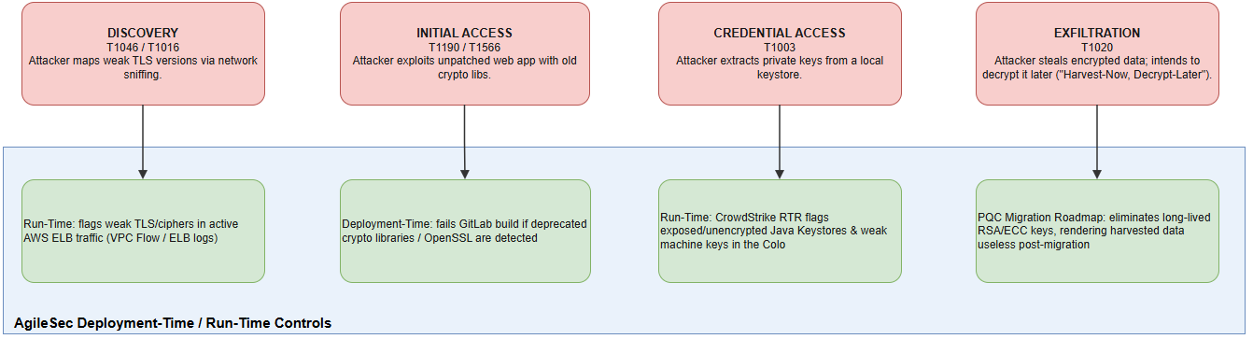
Figure 5 — MITRE ATT&CK Kill Chain Mapping
- Discovery (T1046 / T1016): attackers scan environments for weak network encryption to execute man-in-the-middle interceptions. The Fit: run-time AWS traffic logs (ELB / VPC Flow, Section 4.3) surface exactly which active endpoints are negotiating legacy TLS 1.0/1.1 or vulnerable ciphers, so those AWS security policies can be tightened.
- Initial Access (T1190 / T1566): attackers exploit known software flaws — including compromised cryptographic libraries — to gain initial access. The Fit: the deployment-time GitLab CI/CD scan (Section 4.2) blocks developers from pushing code compiled with deprecated OpenSSL or insecure encryption algorithms, preventing the vulnerability from ever running in AWS.
- Credential Access & Key Theft (T1003): adversaries look for poorly protected private keys and local keystores to compromise identities. The Fit: the run-time CrowdStrike RTR scan in the Colo (Section 4.3) proactively surfaces exposed, unencrypted Java Keystores (JKS) or weak local machine keys before an attacker can scrape them.
- Exfiltration — the "Harvest-Now, Decrypt-Later" Threat (T1020): nation-state adversaries target encrypted enterprise data to steal and store it today, intending to decrypt it once cryptographically-relevant quantum computers emerge. The Fit: the ultimate goal of the AgileSec platform is identifying classic public-key layers (RSA/ECC) so they can be transitioned to post-quantum standards (ML-DSA) via the PQC Migration Roadmap (Section 6.2), rendering previously-stolen data useless to a future quantum adversary.

7. Enterprise Integrations: ServiceNow and Telos Xacta 360
Integrating ServiceNow and Telos Xacta 360 evolves AgileSec from a standalone dashboard into an integrated core data provider for enterprise IT and continuous compliance. This turns what was previously a one-way collection flow into two-way data pipelines: context-aware collection (Section 4.6, already covered) and the compliance push pipelines below.

7.1 ServiceNow Vulnerability Response & ITSM
AgileSec uses the native Keyfactor AgileSec App for ServiceNow Vulnerability Response to eliminate manual security triage.
- Automated Ticket Generation: when a cryptographic vulnerability is discovered — for example, an outdated TLS 1.0 listener on an AWS ALB — AgileSec creates or updates a record in ServiceNow Vulnerability Response.
- Lifecycle Management: ServiceNow maps the finding to the correct Configuration Item (CI) and assignment group (using the CMDB context pulled in Section 4.6). If a ticket passes its remediation SLA, ServiceNow triggers automated escalation through standard IT service workflows.
SLA values (Assumption — not specified in the source material): a starting-point SLA structure is Critical findings (e.g., a publicly-reachable service using SHA-1 or RSA < 2048-bit) remediated within 15 days, High within 30 days, Medium within 90 days, consistent with common vulnerability-management SLA conventions — confirm against your organization's actual policy.

7.2 Telos Xacta 360 Continuous Compliance
Telos Xacta 360 serves as the enterprise Authorizing Official (AO) boundary and cyber risk management system of record. AgileSec integrates directly through Xacta's Data Mesh API to supply evidence for continuous security control validation.
- Control Evidence Automation: AgileSec normalizes CBOM findings and maps them directly against mandated compliance frameworks — such as NIST SP 800-53 Rev 5, FedRAMP, or DoD CC SRG — inside Xacta.
- Control Validation: if AgileSec confirms an AWS Landing Zone account or Colo subnet is using 100% quantum-safe or FIPS 140-3 approved algorithms, it transmits a pass validation state to the corresponding Xacta 360 system assessment project.
- Automated POA&M Creation: if non-compliant cryptography is discovered — such as unencrypted data-at-rest or a non-FIPS-compliant module — AgileSec pushes the validation failure to Xacta through the API, automatically initiating or updating a Plan of Action and Milestones (POA&M) required to retain the system's Authorization to Operate (ATO).

8. Security Considerations for the Platform Itself
The original document did not address the security of the AgileSec platform itself anywhere — a material gap, since the CBOM it produces is, by construction, a complete map of every cryptographic weakness in the enterprise. In the wrong hands that inventory is a target list, not just a compliance artifact. This entire section is new content (Assumption / Recommendation) added to close that gap.
- Data classification: treat the CBOM and any export of it (reports, API responses, dashboard screenshots) as Confidential / Internal-Sensitive at minimum — it enumerates exploitable weaknesses by asset and owner.
- Encryption: the Amazon OpenSearch Service domain must use encryption at rest (AWS KMS-managed key) and enforce TLS for all client and node-to-node traffic; this was not stated in the original material and should be a deployment default, not an option.
- Access control: Web UI access should be role-based (RBAC) at minimum split between read-only (view CBOM, dashboards) and administrative (change scan schedules, policy rules, SDK algorithm mappings) roles, provisioned through the organization's existing identity provider (SSO/SAML) rather than local accounts.
- Audit logging: every view, export, and administrative change in the Web UI should be logged with actor, timestamp, and the specific records or reports accessed, and those logs retained per Section 9's retention policy — this supports both incident investigation and the Xacta 360 continuous-ATO evidence chain (Section 7.2).
- Secrets management: every connector credential (GitLab CI token, CrowdStrike OAuth client secret, ServiceNow and Xacta API credentials) is stored in AWS Secrets Manager, retrieved by the Hub API at runtime (Figure 2), and rotated on a defined cadence (recommend 90 days or per each vendor's own rotation guidance, whichever is shorter) — not stated in the original material.
- Cross-account role hardening: the AgileSec-CrossAccount-Role (Section 3.2) should require an external ID condition on its trust policy, in addition to being read-only, to reduce the confused-deputy risk inherent in any role assumable from 100+ accounts.
- Network exposure: the Hub's ALB is internal-only (Figure 1); no component of this architecture should require a publicly internet-facing listener into the EKS cluster. GitLab CI's push to the Hub API (Pathway B) and the Web UI both terminate at the internal ALB, reached through existing private network paths (VPN / Direct Connect / internal routing) rather than the public internet.

9. Assumptions, Prerequisites & Constraints
These are prerequisites the architecture depends on but which the original material left implicit. Confirm each before treating this blueprint as ready to implement.
- AWS Organizations is already deployed with all 100+ spoke accounts under a single management account, and the management account has the permissions needed to deploy an Organizations-managed CloudFormation StackSet (Section 3.2).
- GitLab is licensed at a tier that supports Group-level CI/CD component definitions, and (Assumption) is GitLab.com SaaS rather than self-managed — confirm, since a self-managed instance changes the network path in Figure 1 (Section 4.2).
- The CrowdStrike Falcon sensor is already installed and licensed with the RTR module on every in-scope Colo host (Section 4.3); hosts without it are invisible to run-time collection.
- ServiceNow Vulnerability Response module is licensed, and the Keyfactor AgileSec App for ServiceNow is installed and configured (Section 7.1).
- Telos Xacta 360 is licensed with Data Mesh API access provisioned for AgileSec's service account (Section 7.2).
- A Direct Connect or site-to-site VPN exists between the Colo and the primary AWS region for any Colo-originated traffic that does not tunnel through the CrowdStrike cloud — for example, if Golden Image Auditing (Section 4.2) runners are hosted at the Colo rather than in GitLab SaaS. (Assumption — confirm this link exists; Pathway C's CrowdStrike RTR traffic does not need it, since it tunnels through the CrowdStrike cloud API instead.)
- CBOM and platform audit-log retention: 13 months (Assumption — a common compliance baseline) unless your FedRAMP / DoD CC SRG obligations (referenced in Section 7.2) mandate a longer specific period, in which case that governs.

10. Definitions & Acronyms
Term | Definition
ALB | Application Load Balancer (AWS)
ATO | Authorization to Operate
CBOM | Cryptographic Bill of Materials — the inventory of cryptographic assets, algorithms, and key material AgileSec compiles
CCR | Cross-Cluster Replication (an OpenSearch feature; considered and not selected for this DR design — see Section 3.4)
CI | Configuration Item (ServiceNow CMDB terminology)
CMDB | Configuration Management Database (ServiceNow)
DR | Disaster Recovery
FedRAMP | Federal Risk and Authorization Management Program
JKS | Java KeyStore — a file format for storing cryptographic keys and certificates
ML-DSA | Module-Lattice-Based Digital Signature Algorithm — a NIST-standardized post-quantum signature algorithm
ML-KEM | Module-Lattice-Based Key-Encapsulation Mechanism — a NIST-standardized post-quantum key-exchange algorithm
POA&M | Plan of Action and Milestones
PQC | Post-Quantum Cryptography
PQCC | Post-Quantum Cryptography Coalition (led by MITRE)
RPO | Recovery Point Objective — maximum tolerable data loss, measured in time
RTO | Recovery Time Objective — maximum tolerable time to restore service
RTR | Real-Time Response — CrowdStrike Falcon's live host-scripting/response engine
TTP | Tactics, Techniques, and Procedures (MITRE ATT&CK terminology)

Appendix A — Assumptions, Corrections & Decisions Log
This appendix is the full record of how the source material's contradictions were resolved, its gaps filled, and its ambiguities interpreted, so every change in this document traces back to a reason. Items marked Your Decision were resolved by your explicit answers; items marked Assumption were resolved using reasonable professional judgment and should be reviewed; items marked Correction are objective fixes (terminology, typos, internal contradictions) made with high confidence.

A.1 — Structural problem (root cause of most other issues)
- The source file was a stitched-together sequence of at least three separate AI-assisted drafting passes, not a single authored document: an original blueprint (Sections 1–6), a patch that replaced Section 3 with a Deployment-Time/Run-Time table plus a duplicate prose restatement of the same content, and a second patch that redefined Section 3 again (ServiceNow CMDB enrichment) and Section 4 again (ServiceNow/Xacta pipelines) — silently dropping the original Section 4 (Operationalization Phases 1–4: CBOM baseline, posture evaluation, remediation ticketing, developer crypto-agility) instead of merging with it.
- Evidence left in the body included first-person chat narration ("Here is the comprehensive, production-ready blueprint..."), emoji section markers, and direct editorial instructions to the reader ("To update your master documentation, replace Section 3... with this structured approach"; "append or update sections 3 and 4 in your notes") — none of which is document content.
- Correction: rebuilt as a single linear document with real Word heading styles, one definitive numbering scheme, all editorial/meta text removed, and every patch's content merged into its logical home rather than left as a sequential overwrite. The original Operationalization Phases 1–4 are preserved in Section 5 and merged with the newer ServiceNow/Xacta ticketing detail rather than deleted.

A.2 — Contradictions resolved
- Correction — "administrative assume-role" vs. "read-only": Section 2 of the source stated the cross-account StackSet role is read-only; its Section 3 called the same role an "administrative assume-role pattern." Standardized to read-only, least-privilege cross-account IAM role throughout (Section 4.3, note).
- Correction — DR pattern misnamed: the source labeled its DR design "Warm-Standby" while describing compute scaled to zero replicas, which is AWS's Pilot Light pattern, not Warm Standby. Renamed throughout (Section 3.1).
- Correction — table vs. prose duplication: the source's "Updated Data Collection Matrix" table and the prose immediately after it said the same thing twice. Kept the table as the quick-reference summary (Section 4.5) and rewrote the prose as expanded narrative detail (Sections 4.2–4.3) rather than a repeat.
- Your Decision — CLI naming ("unified_sensor" vs. "AgileSec CLI"): standardized to "AgileSec CLI (unified_sensor binary)" on first use per section, "AgileSec CLI" thereafter, per your confirmation these are the same tool.
- Correction — terminology standardized throughout: "OpenSearch Database" / "OpenSearch clusters" / "OpenSearch database domain" → Amazon OpenSearch Service domain; "Colo" / "Collocation" / "On-Premises" → Colo (on-premises data center) on first use, Colo thereafter; "CrowdStrike Cloud API" / "CrowdStrike Falcon Cloud API" → CrowdStrike Falcon Cloud API; "100+ AWS Spoke Apts" (diagram typo) → 100+ AWS spoke accounts.

A.3 — Gaps filled with industry-standard/derivable content (not business decisions)
- Added a Definitions & Acronyms glossary (Section 10).
- Added an explicit Assumptions, Prerequisites & Constraints section (Section 9): AWS Organizations already deployed with all accounts under one management account; a GitLab tier that supports Group-level CI/CD components; CrowdStrike Falcon sensor already installed on all in-scope Colo hosts with RTR licensed; ServiceNow Vulnerability Response licensed; Xacta 360 subscription and Data Mesh API access provisioned.
- Added secrets-management detail (Section 8): cross-account role trust should use an external ID condition; CrowdStrike OAuth, ServiceNow, and Xacta API credentials are stored in AWS Secrets Manager and rotated on a defined cadence — none of this was in the source.
- Added security considerations for the platform itself (Section 8) in full: the CBOM is effectively a map of every cryptographic weakness in the enterprise, so it needs encryption at rest/in transit, Web UI RBAC, and audit logging of who viewed/exported CBOM data — entirely absent from the source.
- Added an explicit failback procedure (Section 3.5) — the source described only failover, never the return to primary.
- Added a RACI-style responsibility table for the operationalization phases (Section 5.7) — the source named teams informally but never formally assigned responsibility.
- Added a new-account onboarding note (Section 3.2) — how a newly created AWS account automatically receives the AgileSec cross-account role, implied by "100+ spoke accounts" but never stated.
- Added a PQC Migration Roadmap timeline (Section 6.2) — the source's introduction promises a "multi-year PQC migration roadmap" that is never actually laid out anywhere in the material.
- Added a minimal CBOM data model (Section 4.7) — ServiceNow/Xacta integration explicitly references specific fields (Asset Criticality, Application Owner, Regulatory Classification, CI) implying a model that was never made explicit.

A.4 — Business-decision gaps, resolved by your answers
- OpenSearch DR replication mechanism: scheduled native snapshots to S3 (not continuous cross-cluster replication), default interval documented as hourly (Section 3.4) — the exact interval is flagged as an assumption to confirm.
- RTO / RPO targets: RTO ≤ 24 hours, RPO ≤ 4 hours (Section 3.4).
- DR failover trigger: manual, runbook-driven (Section 3.4–3.5), documented with the residual risk that outage detection itself depends on a monitoring path outside this document's scope.

A.5 — Items resolved by reasonable professional judgment (documented as assumptions, not blocking)
- Jira vs. ServiceNow ticketing (Section 5.3): the source said tickets route to "ServiceNow or Jira" but only detailed a native ServiceNow Vulnerability Response app. Interpreted ServiceNow VR as the flagship, deeply-integrated path and Jira as a basic alternate destination for teams not yet on ServiceNow VR.
- GitLab hosting model (Section 4.2): assumed GitLab.com SaaS, since no internal GitLab infrastructure is described and CI/CD runners are described reaching the Hub "over HTTPS." If GitLab is self-managed, the network path in Figure 1 changes.
- Colo network path for non-CrowdStrike traffic (Section 9): assumed a Direct Connect or VPN exists between the Colo and AWS for any direct traffic not tunneled through CrowdStrike; flagged to confirm.
- CrowdStrike RTR OAuth scope (Section 4.3): recommended narrowing to a custom Falcon role scoped to Real Time Response / Real Time Response Admin only, rather than broad Falcon console administrative rights.
- Scan cadence for CrowdStrike RTR Colo scans (Section 4.3): assumed daily, configurable.
- CBOM/audit data retention (Section 9): assumed 13 months, flagged to confirm against actual FedRAMP/DoD CC SRG obligations.
- Remediation SLA values (Section 7.1): proposed Critical/High/Medium tiers of 15/30/90 days as a starting point.

A.6 — Minor fixes (no judgment required)
- "100+ AWS Spoke Apts" → "100+ AWS spoke accounts" (diagram typo).
- Removed all emoji section markers and chat narration; replaced with plain professional headings.
- Fixed the data-collection table's malformed cell (an orphaned paragraph floating outside the pipe-delimited row structure in the source) by properly nesting it inside the AWS Cloud Infrastructure run-time cell (Section 4.5).
- Applied consistent heading capitalization and numbering throughout; added a table of contents.

Appendix B — List of Figures
Figure | Title | Referenced In
Figure 1 | System Context and High-Level Architecture | Section 2.1
Figure 2 | AgileSec Platform Hub Component Architecture | Section 2.2
Figure 3 | Data Collection Flow: Deployment-Time vs. Run-Time | Section 4.4
Figure 4 | DR Failover Sequence | Section 3.5
Figure 5 | MITRE ATT&CK Kill Chain Mapping | Section 6.3
Figure 6 | Operationalization Process Workflow | Section 5.6
Figure 7 | PQC Migration Roadmap Timeline | Section 6.2
Each figure is also delivered as a separately editable draw.io (.drawio) file with the same numbering (e.g., 01-system-context.drawio), openable directly in diagrams.net / draw.io desktop. Diagram content, component names, and terminology are kept identical to this document's text — if you edit either the document or a diagram going forward, update both so they do not drift apart again the way the original source document's sections did.

